|  |
| --- |
|  |
| SOVY |
| Digital Calculator PO1_DGC_MATH_CALC_CDD |

Table of Contents

1. Document Status 3

2. Document History 4

3. Reference Documents 4

4. Project Description 5

5. Software Context Diagram 5

6. Software features 6

7. Static Architecture 6

8. Component API’s 7

# Document Status

|  |  |
| --- | --- |
| Name | SOVY |
| Version | 1.0 |
| Status | Draft |
| Author | Andrew Ezzat |
| Date | 15/4/2021 |

# Document History

|  |  |  |  |
| --- | --- | --- | --- |
| Version | Author | Date | Change |
| 1.0 | Andrew Ezzat | 15/4/2021 | Initial Creation. |

# Reference Documents

|  |  |  |  |
| --- | --- | --- | --- |
| Ref. No. | Doc. Name | Version | Status |
| 1 | Digital Calculator PO1_DGC_GDD | 1.4 | Proposed |
| 2 | PO1_DGC_SRS_DigitalCalculator | 1.4 | proposed |

# 4.Project Description

“Sovy” is a simple digital calculator that performs basic mathematical operations and displays the operation on an LCD-screen, with an ON/OFF button and keypad for user input.

# 5.Software Context Diagram

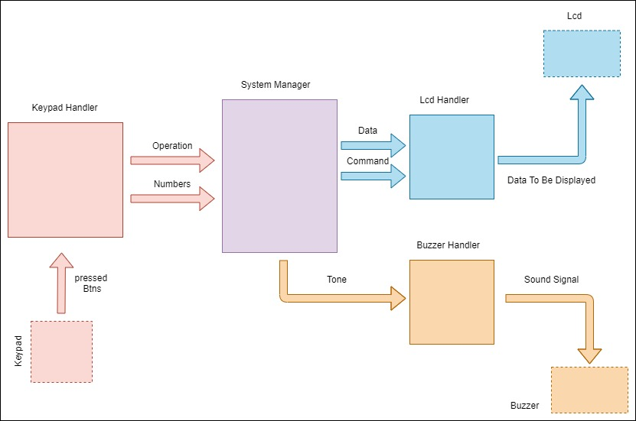

# 6. Software features

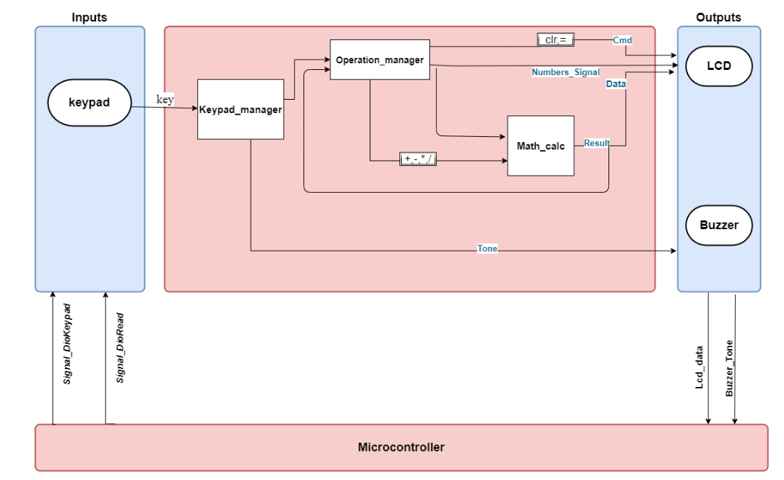

# 

# 7.Static Architecture

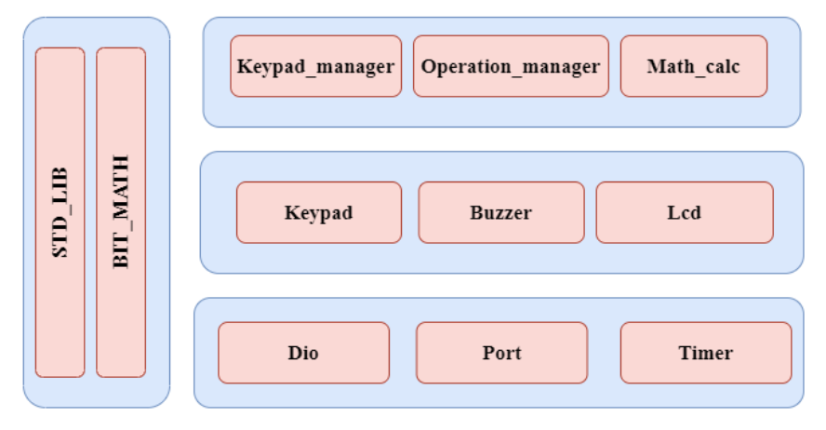

# 8. Component API’s

|  |  |  |  |  |  |
| --- | --- | --- | --- | --- | --- |
| **Req_ID** | PO1_DGC_MATH_CALC_CDD _001-V1.0 | | **Covers** |  | Req_PO1_DGC_GDD_0011-V1.0 |
| **Description:** | It takes two operand and the operation in struct and make the operation on the operands and return it in pointer. | | | | |
| **API** | ReturnStatus_e Math_Calc( Math_Calc_t Data, f32 * result ) | | | | |
| **Parameters** | **Type** | **Name** | | | **Description** |
| Math_Calc_t | Data | | | It is Srtuct that contain :  f16 operand_1,  f16 operand_2,  u8 operation |
| f32 * | Result | | | It is pointer that the result of the operation will be saved in. |
| **Return** | **Type** | **Name** | | | **Description** |
| ReturnStatus_e | _____ | | | STD_ERORR  E_OK -> If operation performed successful it returns 0  E_NOK -> If operation performed **not** successful it returns 1 |
| **Algorithm** |  | | | | |